Basic Literacy

Discussion Forum Suggestions

# Discussion Forums

There are a number of discussion forums in each course. These are currently empty. As a facilitator, you can add the topics you wish here. We have listed suggested topics for each forum.

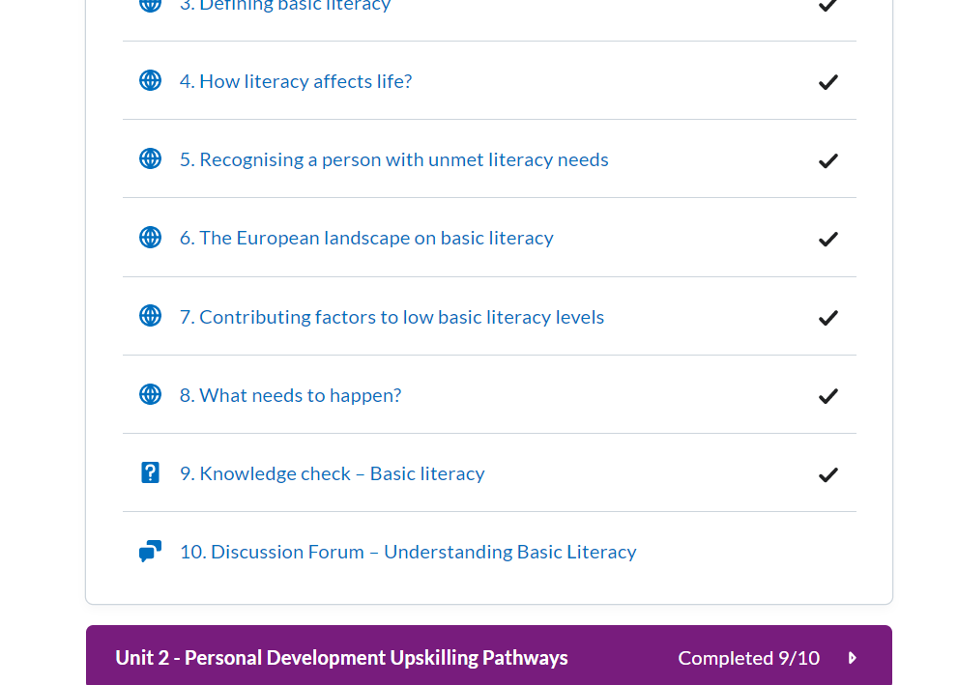

# How to use discussion forums

Click on the Discussion topic and **start a new thread** to edit

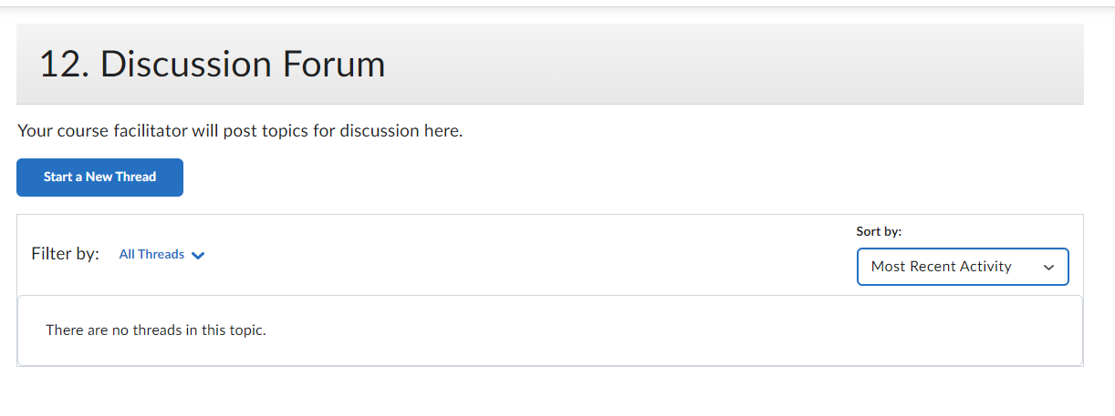

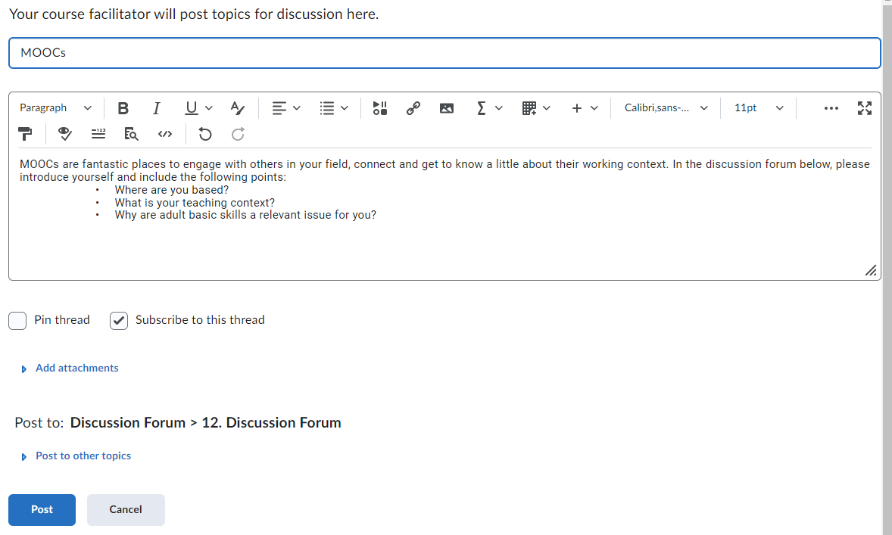

Click **‘post’** to create the topic

# Badges:

Learners will get a Digital badge if they post in each discussion forum. They can either reply to a thread or start their own thread.

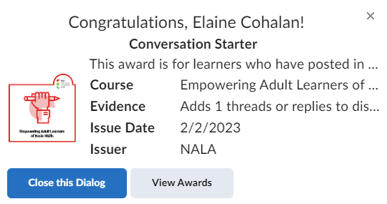

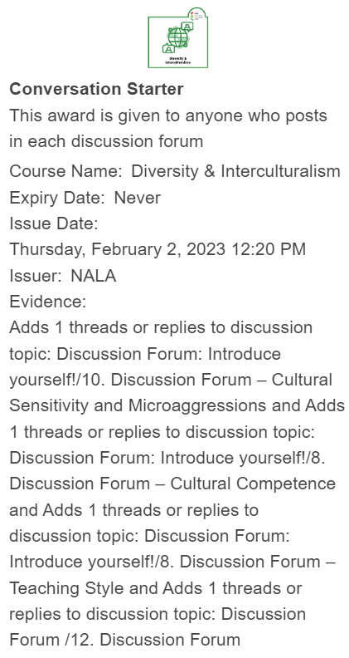

*Unit 1:*

*10.* *Discussion Forum*

Topics suggested for discussion:

1. MOOCs are fantastic places to engage with others in your field, connect and get to know a little about their working context. In the discussion forum below, please introduce yourself and include the following points:

• Where you are based?

• What your teaching context its?

• Why adult basic skills are a relevant issue for you?

2. What do you know about your country's situation in regards to adults’ basic skills? Reflect on differences among demographic groups too! Endeavour to compare beliefs and research-based evidence! Use the [OECD report on PIAAC results](https://www.oecd.org/skills/piaac/publications/countryspecificmaterial/#d.en.489838) cited among further resources for example to get an insight into country specific data!

3. Take a look at the infographic in lesson “What needs to happen”! Choose an area where your work can make a difference and share your thoughts!

4. What does basic literacy look like in your context?

5. What are some challenges your learners have related to low literacy? How useful the tips in lesson “Recognising a person with literacy difficulties” are for you?

*Unit 2:*

## *10.* *Discussion forum - Personal Development Upskilling Pathways*

Topics suggested for discussion:

1. What do you know about your country's situation on the subject of adults’ skills and participation in adult learning? Endeavour to compare beliefs and research-based evidence!

The [*Adult education in Europe 2019 - A civil society view*](https://eaea.org/wp-content/uploads/2019/12/Country-Reports-2019.pdf) EAEA report offers you country specific information.

2. What do you know about your country's status regarding the implementation of the Upskilling Pathways recommendation?

Look into the Eurydice report on [*Adult education and training in Europe – building inclusive pathways to skills and qualifications*](https://op.europa.eu/en/publication-detail/-/publication/827fcd9c-1a8c-11ec-b4fe-01aa75ed71a1/language-en/format-PDF/source-232128473) for country specific information and European comparison.

3. Which of the three steps of Upskilling Pathways represents the highest challenge in your country?

4. How much do (or could) you apply the three-step approach in your work as a tutor?

5. Look into and take the CITO[SkillsChecker](https://www.skillschecker.ie/)! How relevant and useful do you find this tool? Could you use it in your context?

*Unit 3:*

## *9.* *Discussion forum – Learning Resources for Adult Basic Skills*

Topics suggested for discussion:

1. Is there an adult basic skills framework available in your country? If not, have you used any European competence frameworks? How do (or could) you apply them in your work?

2. Please open the [Norwegian competence goals for basic skills](https://www.kompetansenorge.no/contentassets/6c78ef4022c948348f473f322e00a07d/lm_publ_engelsk_siste.pdf)

a. Choose a competence goal (eg. “*Read and understand brief texts using frequently occurring and familiar words” as a competence goal for reading and writing at levels 1-2*).

b. Identify examples (on pages 6-8, 14-15 or 20-21) which correspond to the chosen competence goal (eg. “*Read text messages from family members*” corresponds to “*Read and understand brief texts using frequently occurring and familiar words”* etc.).

c. Formulate and share at least two new everyday examples of the chosen competence goal based on your experience with your learners.

3. Open NALA’s [Getting started in adult literacy and numeracy](https://www.nala.ie/publications/adult-literacy-tutor-training-resource-pack/) tutor training resource pack for initial tutor trainings.

a. Select a section that seems the most appealing to you.

b. Read it through, and choose a resource (activity, handout etc.) that reminds you of a challenge you met in your professional activity.

c. Share the challenge and how this resource relates to it.

*Unit 4:*

## *11.* *Discussion forum – Best Practice Teaching for Basic Skills*

Topics suggested for discussion:

1. Choose one European best practice in adult learning and basic skill development that you feel relevant to your work, context. Share your choice and explain its relevance.

2. What do you think about the five perspectives of good teaching as explained by TPI? Take the TPI or choose a perspective you think is dominant in your teaching. Identify elements in your teaching practice that demonstrate how you apply that perspective!

3. Take the [DigCompEdu CheckIn](https://ec.europa.eu/eusurvey/runner/CheckIn_HE_v2021_EN) self-assessment. What is your experience? How much does it reveal areas with development potential for your own digital skills?

4. Check out EBSN or NALA’s literacy tutor training! Are any of them appealing to you? Register and share your experiences with the group!

5. Choose a literacy blog that interests you, check it out, and think of ways how you could implement some of their ideas and suggestions into your own teaching practice. Share your findings with the group!

6. How inspirational do you find Veronica Poole’s story? Is there any similarly inspirational case in your professional experience you wish to share with the group?